Grade 7 Accelerated · Unit 4 · Lesson 1  Adding and Subtracting in Scientific Notation  Question Bank - Additional 4.01 | Name______________________  Date______________________  Period____________________

Show your work. Circle your final answer.
For questions 1 through 6, add or subtract. Write each answer in scientific notation.
1. 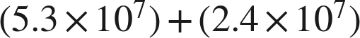

2.

3. 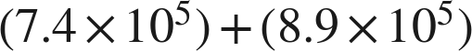

4.

5. 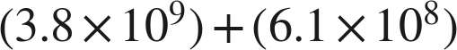

6.

Real quantities.
7. Mars's diameter is about  kilometers. Earth's is about  kilometers.
a. What is the sum of the two diameters?

b. How much larger is Earth's diameter than Mars's?

8. A charity raised about  dollars in its first year and about  dollars in its second.
a. How much did it raise in the two years together?

b. How much more did it raise in the second year than in the first?

Working backwards.
9. Find the missing number in each equation.
a.

b.

c. 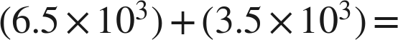 ______

Reading someone else's work.
10. Malik writes . Name the two mistakes he made, and give the correct sum.

11. Which is the value of 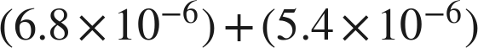, written in scientific notation?
○ A. 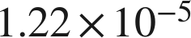
○ B. 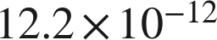
○ C. 
○ D. 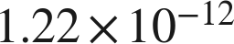

12. Select ALL of the expressions whose value is 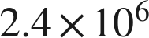.
□ A. 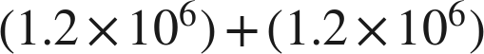
□ B. 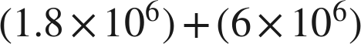
□ C. 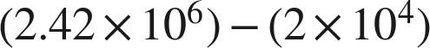
□ D. 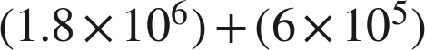
□ E. 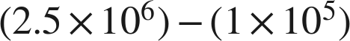
□ F. 